Data Type
Data Type represents the type of information stored in the memory location or Column. Each column should have only one Data Type.
Change Data Type of a Column in Power BI
When you import or load a table from any data source, Power BI will automatically detect the data type of a column. However, there may be some situations where Power BI might get them wrong. For example, it may consider amounts, values, or even dates as the text. Now we will see how to Change Data Types of a Column in Power BI with example. Changing data type of the column is important as DAX functions have special data type requirements and also filtering options will change based on data type of the column.
In Query Editor or Power Query you can change the Data Type of a column in different ways.
Approach 1
In the below image for Units Sold Column, Power BI identified it as string column. But actually we have Decimal Numbers as that column values.
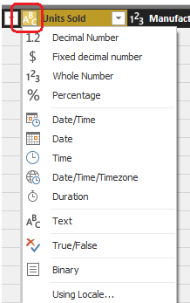
So to change the data type, select the Column for which you want to change the data type. Next, click on the left corner of the column header which is marked in Red Box. Then select the data type which is appropriate, here Decimal Number.
Changing data type of a column will open the following pop up window. You can Choose “Replace Current” to update current step or also you can choose “Add new step” to add a new transformation step to the Query.
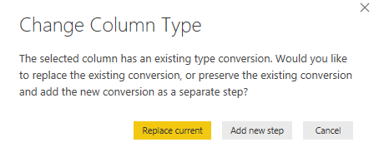
Approach 2
Select the Column name that you want to alter the data type, and click on the Data Type button under the Home tab in Power Query Ribbon.
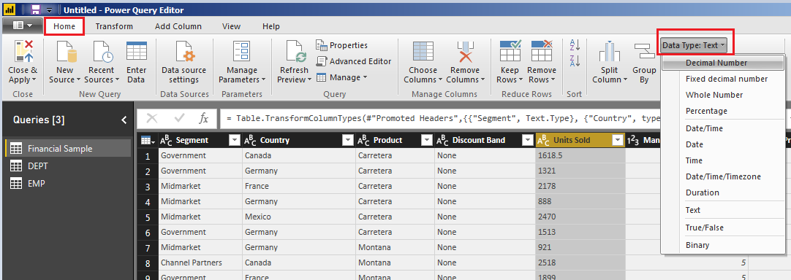
Approach 3
Select the Column that you want to change the data type and right-click on it will open the context menu. Select the Change Type and then select the data type from the list. For now, we are selecting the Decimal Number.
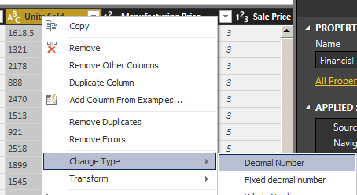
Filtering select Rows in Power Query / Filters in Power Query
Data Type of column has impact on filtering options available. Filter options changes with respect to data types. Before going to filter rows check the data types of the columns.
“Text Filtering Options Are Case Sensitive”.

Filter a column using an Auto Filter / Basic Filtering
- Select the column that you need to filter.
- Click the down arrow ( ).
- Uncheck the Select All box to deselect all Column Values.
- Select the column values you want to include in your table.
- Click OK.
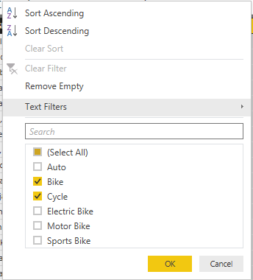
“Search Bar is Case Insensitive”.
Note:
Be careful if you are filtering the rows using Search Bar. Always look at the M code return by Power Query and cross check it is filtering as expected.
Basic Filtering is good only if you want to do equity filtering for values that exists in the current data set, however it won’t work correctly if you want to check ranges, or contains or things that is not an exact equity filter. Advanced Filtering is the correct way of filtering in Power Query, and there are advanced filters for all types of data types; Numbers, Text, Date…

When you filter a column, only the top 1,000 distinct values in the column will load into the filter list. If there are 1,000 or more values in the column in Query Editor that you are filtering, a message will appears indicating that the list of values in the filter list may be incomplete, and the Load more link is shown. Click the Load more link to load another 1,000 distinct values.
If exactly 1,000 distinct values are found again, the list is displayed with a message stating that the list could still be incomplete.
If less than 1,000 distinct values are found, the full list of values is shown.
Filter a Column using Text Filters
In addition to the “Auto Filters” or Basic Filtering, you can filter a Text values using the Text Filters context menu.
Click the down arrow ( ) of the column containing a Text values you want to filter on.
Click Text Filters and select the filter option required from Context Menu.
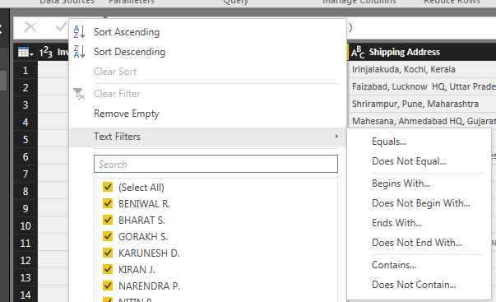

Filter a Column using Number Filters
In addition to the “Auto Filters”, you can filter Number values using the Number Filters Context Menu.
To filter a column using Number Filters, Click the down arrow ( ) of the column containing a Number values you want to filter on.
Click Number Filters, and select the filter option required from Context Menu.
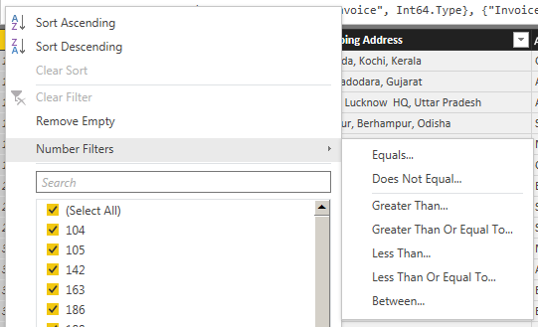
Filter a Column using Date Filters
In addition to the “Auto Filters”, you can filter Date values using the Date Filters Context Menu.
To filter a column values using Date Filters, Click the down arrow ( ) of the column containing Date values you want to filter on.
Click Date Filters, and select the filter option required from Context Menu.
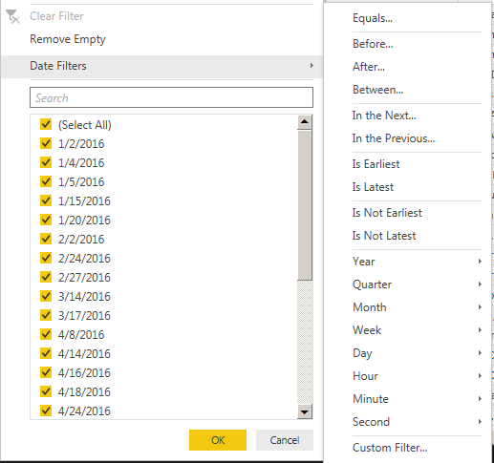
Filter Multiple Columns
To filter multiple columns, select an additional column, and repeat one of the column filter steps. AND Operation will be performed between the columns if you apply filters on multiple columns individually.
Other way is by Using Advanced option in Filter Rows you can apply filters on multiple columns at a time. Here you can select And / Or operation between columns.
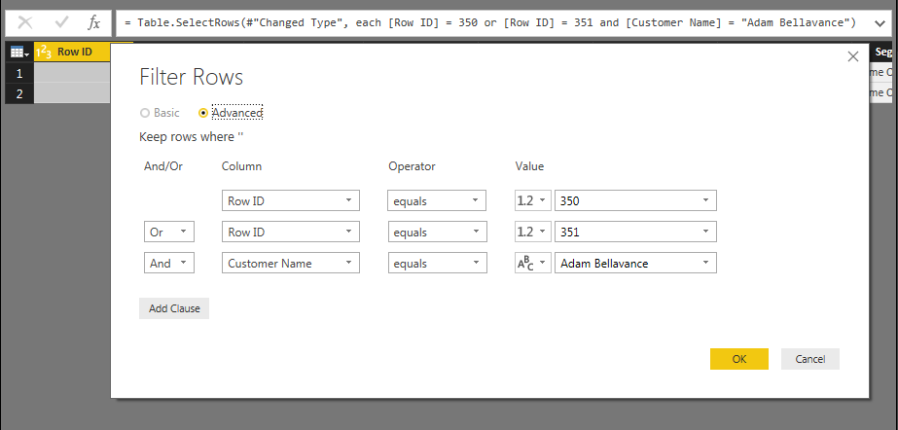
In below image we applied filters on Row ID and Customer Name Column and you can see M Language Code.
